**A GRAFF**

**2231290**

**Lab 5.1 Threats to computer security**

NZCS (New Zealand Computing Security)

New Zealand Computing Security has branches in Whanganui, New Plymouth, and partners throughout New Zealand. The services on offer are Cyber security services – Security audits, Staff training, Ransomware protection and Proactive cyber defence.

Other services are online backups, domain and hosting, cloud, network design, hardware and software and internet. The company has 13+ staff and have looked after many lawyer firms and other businesses with their computing/security networks around New Zealand for over ten years plus according to client testimonies.

There are no indications of NZCS hiring or any listed NZ Government partners.

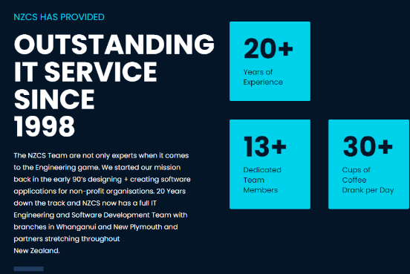

Defend

Defend is a NZ Owned and Operated firm based in Auckland and Wellington. Services include Threat Protection, Threat Detection, Threat Analysis, Threat Intel, Incident Response, Service Management, Resourcing, Governance and Compliance.

There is no indication of how much staff but we can see a career page. Defend is hiring staff and has listed many job opportunities that all relates to information security/technical field. .

